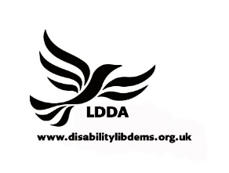 | Liberal Democrat  Disability Association  www.disabilitylibdems.org.uk  Working to Raise Awareness and Understanding of Disability

Membership of LDDA is £6.00 for unwaged and £12.00 for waged.

Please make your cheques payable to LDDA.
BLOCK CAPITALS PLEASE

Name of Member:

Party Membership Number:

Address of Member:

Post Code

Phone Number:

E-mail Address:

Local Party:

Region:

Please state if you wish for a standing order form to be sent out to for subsequent subscriptions. YES/NO

Do you wish to receive newsletters by email YES/NO?

Do you wish to receive the newsletters in an alternative format YES/NO?

If so, what format? CONTRAST/LARGE PRINT (18 POINT)/ LARGE PRINT (36 POINT)/AUDIO

Do you wish to join the LDDA Facebook group? YES/NO

PLEASE RETURN TO-
MRS G ROULSTON,
98, COLESMEAD ROAD,
REDHILL,
SURREY RH1 2EQ

(If you return this form the Liberal Democrats locally and nationally may use information provided, including your political views, to further our objectives, share it with our elected representatives and/or contact you in the future using any of the means provided. Some contacts may be automated. You may opt out of some or all contacts or exercise your other legal rights by contacting us. Further details are in our Privacy Policy at www.libdems.org.uk/privacy.

